**SPORTY SHOES - E.COMM STORE**

PROPOSAL - Version V1.0​

# Presented By : Ajunumasa Sadanandan

## Git hub link : <https://github.com/ajunu/Phase3FinalProject/tree/master/phase3-master>

# TABLE OF CONTENTS

|  |  |  |
| --- | --- | --- |
| S.No | Topic | Page No |
| 1 | Project Overview | 2 |
| 2 | Goals | 2 |
| 3 | Road Map | 2 |
| 4 | Application Specification | 3 |
|  | 4.1 Product Capability | 3 |
|  | 4.2 Appearance and UI | 4 |
| 5 | Flow Chart and Flow Explanation | 5 |
| 6 | Requirement Analysis | 9 |
|  | 6.1 Epics | 10 |
|  | 6.2 User Stories | 10 |
| 7 | Sprint Planning | 11 |
|  | 7.1 Sprint 1 | 12 |
|  | 7.2 Sprint 1 Report | 13 |
|  | 7.3 Sprint 2 | 15 |
|  | 7.4 Sprint 2 Report | 16 |
| 8 | Tools and Technologies | 17 |
| 9 | Source Code Access | 18 |
| 10 | Conclusion | 18 |

# 1. PROJECT OVERVIEW

​**Sporty Shoes​** is a company that manufactures and sells sports shoes. They have a walk-in store, and now, they wish to launch their e-commerce portal ​**sportyshoes.com​**.

**Sportyshoes.com​** is an e-commerce store focused on selling sports shoes. Users are able to signup/login to the portal, create a profile and select from a wide-variety of shoes available and purchase them. There is also an admin backend with additional privileges.An extensive Database is developed and organized for storing user details, product details and purchase details.

# 2. GOALS

The expected goals and task to be achieved on a high level are as follows:

1. Create a front end website through which users can interact and purchase shoes.
2. Create an admin backend with additional privileges to manage the website.
3. Develop and manage a database for storing user details ,product details and purchase information.
4. Stable and optimized code.
5. To deliver a high-end quality product as early as possible.

# 3. ROADMAP

|  |  |  |
| --- | --- | --- |
| S.No | Task | No. of Days |
| **1.** | **Create Specification Document……………………………………………………………..** | **2** |
|  | 1.1. Product Capability Analysis | 1 |
|  | 1.2 Appearance and UI Design | 1 |
| **2.** | **Create Flow Chart……………………………………………………………………………..** | **1** |
| **3.** | **Identify User stories and create product backlog……………………………………….** | **1** |
| **4.** | **Sprint Planning………………………………………………………………………………...** | **12** |
|  | 4.1 Sprint-1 | 5 |
|  | 4.1.1 End of Sprint-1 Report | 1 |
|  | 4.2 Sprint-2 | 5 |
|  | 4.2.1 End of Sprint-2 Report | 1 |
| **5.** | **Analyze source code stability and code optimization………………………………….** | **1** |
| **6.** | **Documentation………………………………………………………………………………...** | **1** |
| **7.** | **Product Release……………………………………………………………………………….** | **1** |
|  | **TOTAL NO: DAYS** | **19(APPROX.)** |

# 4. SPECIFICATIONS

## 4.1 Product Capability​

The product development can be divided into 3 major parts:

1. User Front End
2. Admin Backend
3. Database creation and management.

Let’s look into more detailed specifications of each of the components.

### 1. USER FRONT END

Users interact with the service using this front end website. The demanded specifications are as follows:

1. Users should be able to login or register to the portal.
2. Users should be displayed with all the available products and make a purchase.
3. Order details should be accessible to the user.

### 2. ADMIN BACKEND​

This is the control panel site which provides a dashboard to the website admin to see and manage all the details. ​The demanded specifications are as follows:

1. An admin login page where the admin can change the password after login, if he wishes
2. Manage the products in the store including categorizing them
3. Browse the list of users who have signed up and be able to search users
4. See purchase reports filtered by date and category

### 3. DATABASE​

For storing, managing and retrieving the website data. Following data are handled: a) User Details

1. Product details
2. Purchase Details

​**Other expected capabilities:**

a) Application should not close, exit, or throw an exception if the user specifies an invalid input.

## 4.2 Appearance and UI​

The final application is expected to have an appearance and UI similar to the given designs.

a) HOME PAGE

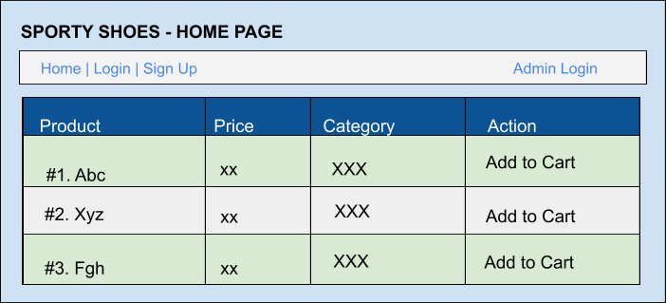

​*Fig: User Home Page*

a) ADMIN HOME PAGE

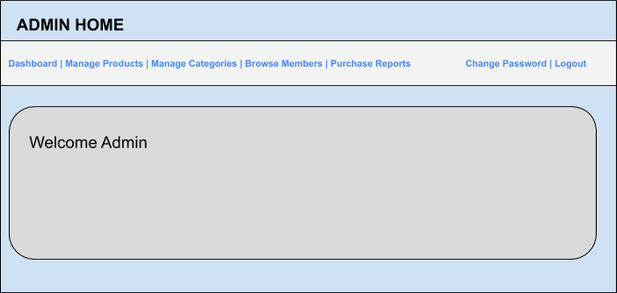 ​*Fig: Admin Home Page*

# 5. FLOW CHART

## 5.1 Flow of the application -As a User

STEPS:

1. User launches application and is displayed with Home Page
2. User tries to select product by clicking “Add to Cart”
3. User is prompted to login or register to the site to get access

​ **Scenario 3.1 : ​SIGN UP**

3.1.1 User is displayed with SIGN UP form

3.1.2 User submits mandatory details and clicks SUBMIT

3.1.3 User successfully logs in to site HOME PAGE

​ **Scenario 3.2 ​LOGIN**

3.2.1 User is displayed with SIGN IN form

3.2.2 User submits mandatory details and clicks SUBMIT

3.2.3 User successfully logs in to site HOME PAGE

Additional Scenarios:

​ **Scenario 3.3 ​INCORRECT CREDENTIALS**

* 1. Appropriate Messages are displayed
  2. User tries login again

1. User is at Home Page, displayed with available product details
2. User adds a product to cart and goes to CART
3. User is at the CART page. Users can verify the order and remove items if required.
4. User proceeds to CHECKOUT
5. User confirms the details
6. User is navigated to PAYMENT GATEWAY
7. User successfully makes payment and is shown a success message. User is shown options for next action.

​**Scenario ​** ​**10.1​** : ​**VIEW ORDER DETAILS**

* + 1. User is redirected to VIEW ORDER HISTORY Page
    2. User is able to view all orders made using the account

​**Scenario ​** ​**10.2​** : ​**GO TO HOME**

10.2.1 User is redirected to HOME page.

1. Optionally, user can “Edit Profile” from the link provided in Menu Tab
2. User logs out from the application gracefully.

## 5.2 FLOW CHART

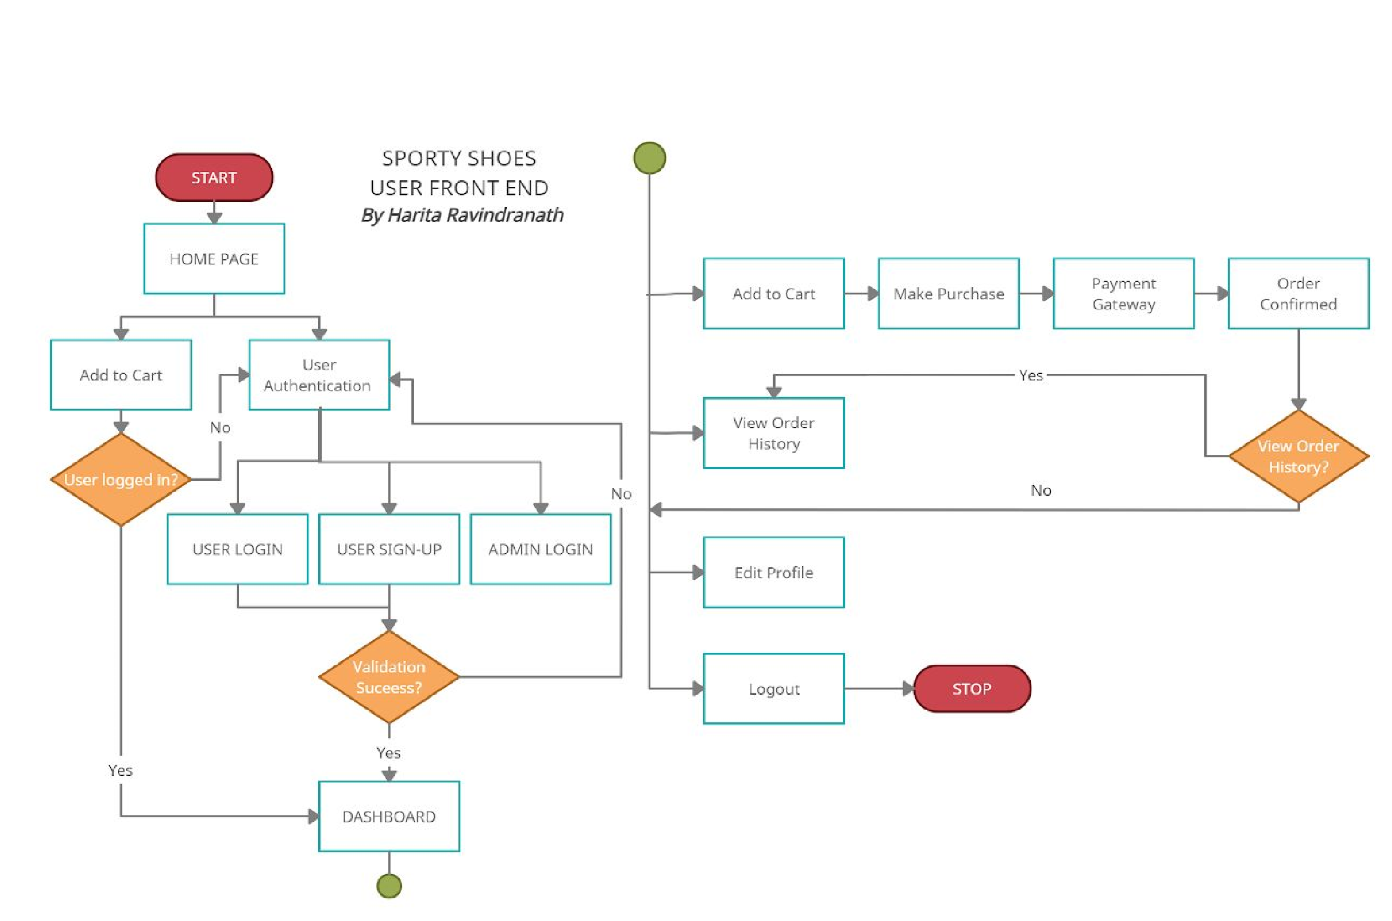

F​ ig: Flow Chart

## 5.3 Flow of the application -As admin

​ STEPS:

1. Admin User tries to login to the application

​ **Scenario 1.1 ​INCORRECT CREDENTIALS**

1.1.1 Appropriate Messages are displayed

1.1.2 Admin tries login again

​ **Scenario 1.2 ​CORRECT CREDENTIALS**

1. Admin Successfully logins and is navigated to HOME Page
2. Admin is able to see dashboard containing available options

​ **Scenario 3.1 Admin clicks on SET UP PRODUCTS option**

**​** 3.1.1 Admin can view all existing products

3.1.2 Admin can add new product

3.1.3 Admin can edit existing product details

3.1.4 Admin can delete existing product details

​**Scenario 3.2 Admin clicks on SET UP CATEGORY option**

3.2.1 Admin can view all existing categories

3.2.2 Admin can add new category

3.2.3 Admin can edit existing product details

3.2.4 Admin can delete existing product details

​**Scenario 3.3 Admin clicks on BROWSE MEMBERS option and sees all existing registered user details.**

**​** 3.3.1 Admin can search for users

**Scenario 3.4 Admin clicks on PURCHASE REPORTS option**

**​** 3.4.1 Admin can view all purchase details based on users and category

​ **Scenario 4 CHANGE PASSWORD​**

4.1.1 Admin selects MY PROFILE option

4.1.2 Admin fills out details to change password

4.1.3 The passwords are validated and updated

​**Scenario 5 ​LOGOUT**

5.1 User logs out from the application gracefully

### 5.4 Flow Chart

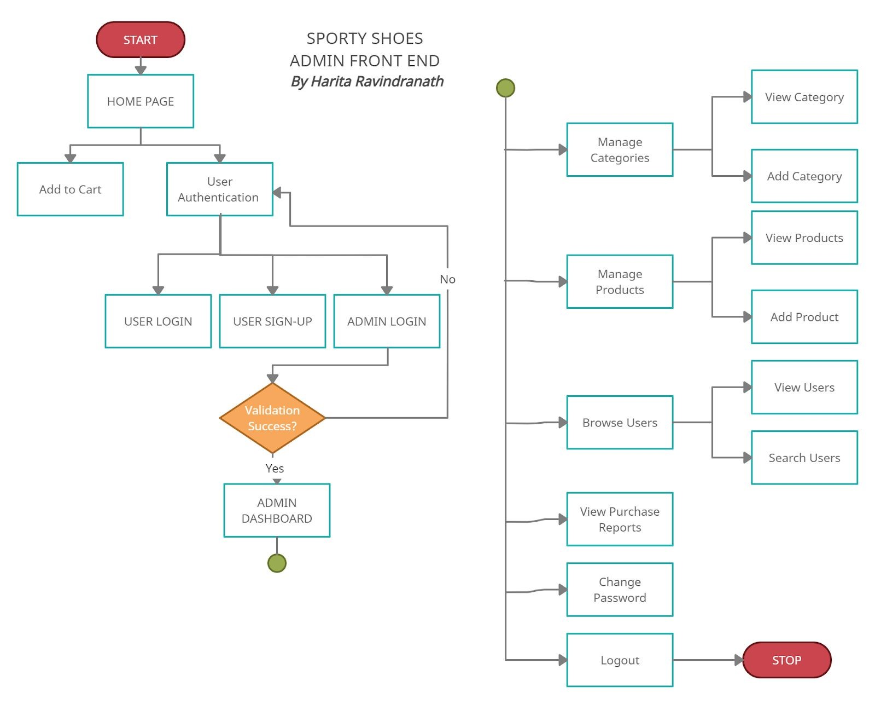

# 6. REQUIREMENT ANALYSIS

Based on the customer requirements, USER STORIES were identified and grouped under 5 main

EPICS. JIRA tool was used for project management. Using User stories, the initial product backlog was created.

## EPICS

|  |  |  |
| --- | --- | --- |
| EPIC  NO | EPIC NAME | Description |
| 1 | VALIDATION | Deals with development of login and signup & corresponding validations |
| 2 | HOME | Deals with development of page and all associated links and pages. |
| 3 | PURCHASE | Deals with development of E2E purchase journey |
| 4 | MANAGE | Deals with development of Admin dashboard page and requires privileges. |
| 5 | LOGOUT | Deals with development of logout functionality |

## USER STORIES

|  |  |  |  |  |
| --- | --- | --- | --- | --- |
| No. | JIRA-KEY | EPIC | FUNCTIONALITY | USER STORY |
| 1 | ECOM-1 | VALIDATION | Login | As a user, I should be able to launch the site and navigate to login page |
| 2 | ECOM-2 | VALIDATION | SignUp | As a new user, I should be able to launch the site and navigate to signup page |
| 3 | ECOM-3 | VALIDATION | Login | As an admin, I should be able to launch the site and navigate to admin login page |
| 4 | ECOM-4 | VALIDATION | Login | As a user, when I provide incorrect credentials, I should be displayed with an appropriate error message and not able to access the site. |
| 5 | ECOM-5 | VALIDATION | SignUp | As an new user, I should be able to register to the site and navigate to home page successfully |
| 6 | ECOM-6 | VALIDATION | Login | As an existing user,I should be able to login to the site providing my credentials and navigate to home page successfully |
| 7 | ECOM-7 | HOME | View Home | As an admin user, I should be able to login to the site and validate the admin home page. |
| 8 | ECOM-8 | HOME | View Products | As a logged-in user, I should be displayed with all available products in the Home page |
| 9 | ECOM-9 | PURCHASE | Add to Cart | As a user, I should be able to products to my cart and checkout |
| 10 | ECOM-10 | PURCHASE | Remove from Cart | As a user, after adding products to my cart, I should be able to remove them |
| 11 | ECOM-11 | PURCHASE | Make Payment | As a user, I should be able to confirm my order by making payment |
| 12 | ECOM-12 | PURCHASE | Order Success | As a user, after successful order placement, I should be displayed with appropriate message |
| 13 | ECOM-13 | PURCHASE | View Orders | As a user, I should be presented with option to view my purchase history |
| 14 | ECOM-14 | HOME | Edit Profile | As a user, I should be able to edit my profile details. |
| 15 | ECOM-15 | LOGOUT | Logout | As a logged-in user, I should be able to successfully logout. |
| 16 | ECOM-16 | MANAGE | Manage  Categories | As an admin user, I should be able to add categories,edit them and delete them |
| 17 | ECOM-17 | MANAGE | Manage Products | As an admin user, I should be able to add products,edit them and delete them |
| 18 | ECOM-18 | MANAGE | Browser Users | As an admin user, I should be able to browse through registered user details and search for users |
| 19 | ECOM-19 | MANAGE | Purchase Report | As an admin user, I should be able to view purchase history categorized by user and category |
| 20 | ECOM-20 | HOME | Change Password | As an admin user, I should be able to change password |
| 21 | ECOM-21 | LOGOUT | Logout | As a logged-in admin user, I should be able to successfully logout. |

# 7. SPRINT PLANNING

The software was planned to develop in a 100% Agile way. Inorder to proceed with application coding, two sprints were planned. JIRA tool was used for Sprint planning. User stories were pulled from the product backlog and the sprint activity status was monitored using Kanban board.

## 7.1 SPRINT 1

Planned Goals:​

1. Create Login page
2. Create Sign Up page
3. Implement Logout Functionality
4. Implement Home Page
5. Implement Purchase E2E functionality

Planned Days​ :​ 1 week (5 days)

Planned No. of User Stories :​ 12​

|  |  |  |  |  |
| --- | --- | --- | --- | --- |
| No. | JIRA-KEY | EPIC | FUNCTIONALITY | USER STORY |
| 1 | ECOM-1 | VALIDATION | Login | As a user, I should be able to launch the site and navigate to login page |
| 2 | ECOM-2 | VALIDATION | SignUp | As a new user, I should be able to launch the site and navigate to signup page |
| 3 | ECOM-4 | VALIDATION | Login | As a user, when I provide incorrect credentials, I should be displayed with an appropriate error message and not able to access the site. |
| 4 | ECOM-5 | VALIDATION | SignUp | As an new user, I should be able to register to the site and navigate to home page successfully |
| 5 | ECOM-6 | VALIDATION | Login | As an existing user,I should be able to login to the site providing my credentials and navigate to home page successfully |
| 6 | ECOM-8 | HOME | View Products | As a logged-in user, I should be displayed with all available products in the Home page |
| 7 | ECOM-9 | PURCHASE | Add to Cart | As a user, I should be able to products to my cart and checkout |
| 8 | ECOM-10 | PURCHASE | Remove from Cart | As a user, after adding products to my cart, I should be able to remove them |
| 9 | ECOM-11 | PURCHASE | Make Payment | As a user, I should be able to confirm my order by making payment |
| 10 | ECOM-12 | PURCHASE | Order Success | As a user, after successful order placement, I should be displayed with appropriate message |
| 11 | ECOM-14 | HOME | Edit Profile | As a user, I should be able to edit my profile details. |
| 12 | ECOM-15 | LOGOUT | Logout | As a logged-in user, I should be able to successfully logout. |

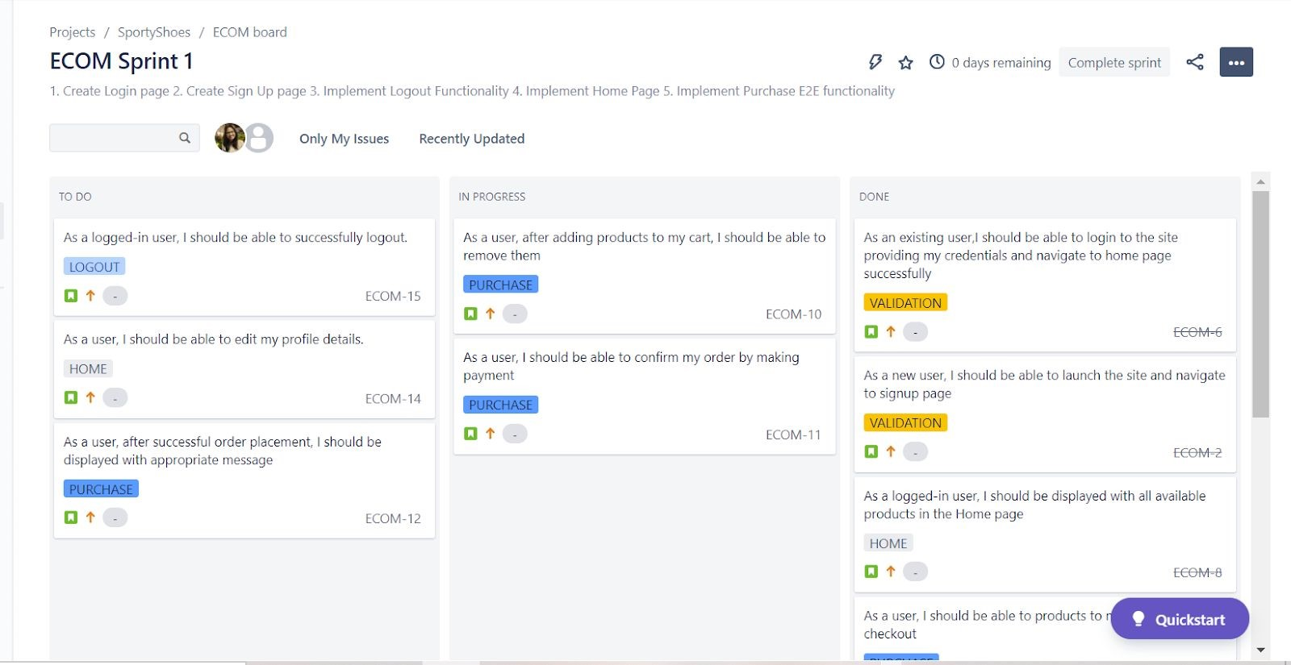

​ *Fig: JIRA Sprint-1 Kanban Board*

## 7.2 SPRINT 1 - REPORT

The sprint was completed successfully and all the planned goals were achieved within time.

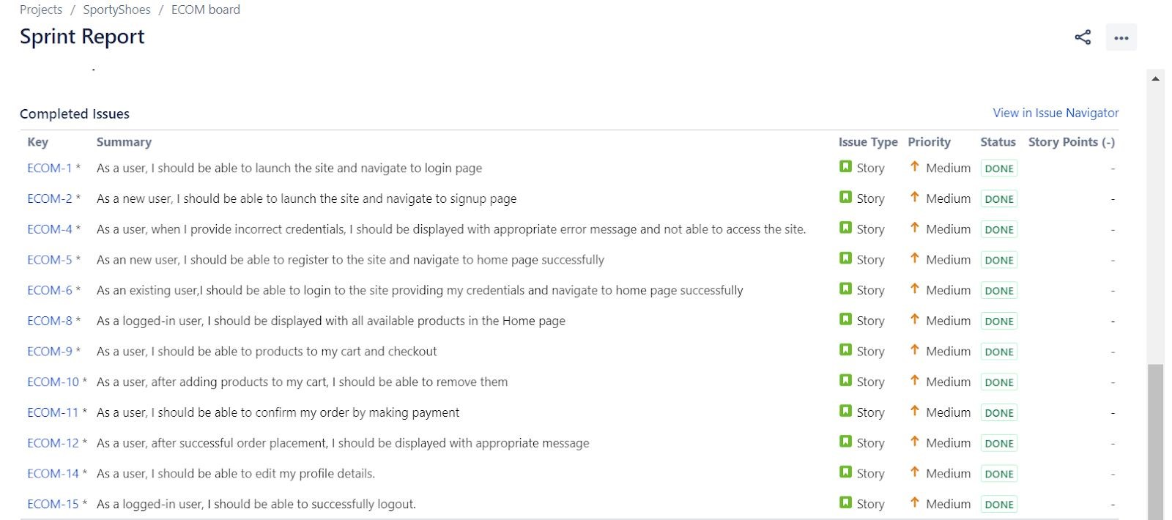

​

*Fig: JIRA Sprint-1 Issue Status*

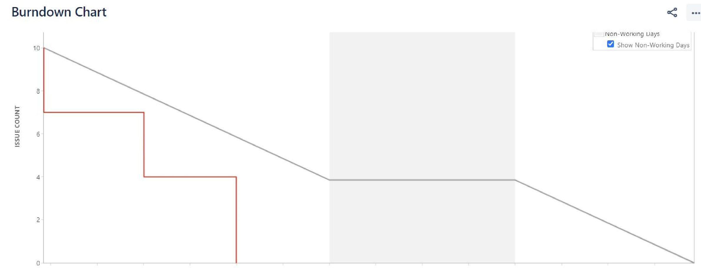

*​*

​

*Fig: JIRA Sprint-1 Burndown Chart*

## 7.3 SPRINT 2

​Planned Goals:

1. Admin Home Page
2. Manage Product & Category Details
3. Browse User Details
4. Purchase History
5. Change Password

Planned Days​ :​ 1 week (5 days)

Planned No. of User Stories :​ 10​

|  |  |  |  |  |
| --- | --- | --- | --- | --- |
| No. | JIRA-KEY | EPIC | FUNCTIONALITY | USER STORY |
| 1 | ECOM-4 | VALIDATION | Login | As a user, when I provide incorrect credentials, I should be displayed with an appropriate error message and not able to access the site. |
| 2 | ECOM-7 | HOME | View Home | As an admin user, I should be able to login to the site and validate the admin home page. |
| 4 | ECOM-13 | PURCHASE | View Orders | As a user, I should be presented with option to view my purchase history |
| 5 | ECOM-16 | MANAGE | Manage  Categories | As an admin user, I should be able to add categories,edit them and delete them |
| 6 | ECOM-17 | MANAGE | Manage Products | As an admin user, I should be able to add products,edit them and delete them |
| 7 | ECOM-18 | MANAGE | Browser Users | As an admin user, I should be able to browse through registered user details and search for users |
| 8 | ECOM-19 | MANAGE | Purchase Report | As an admin user, I should be able to view purchase history categorized by user and category |
| 9 | ECOM-20 | HOME | Change Password | As an admin user, I should be able to change password |
| 10 | ECOM-21 | LOGOUT | Logout | As a logged-in admin user, I should be able to successfully logout. |

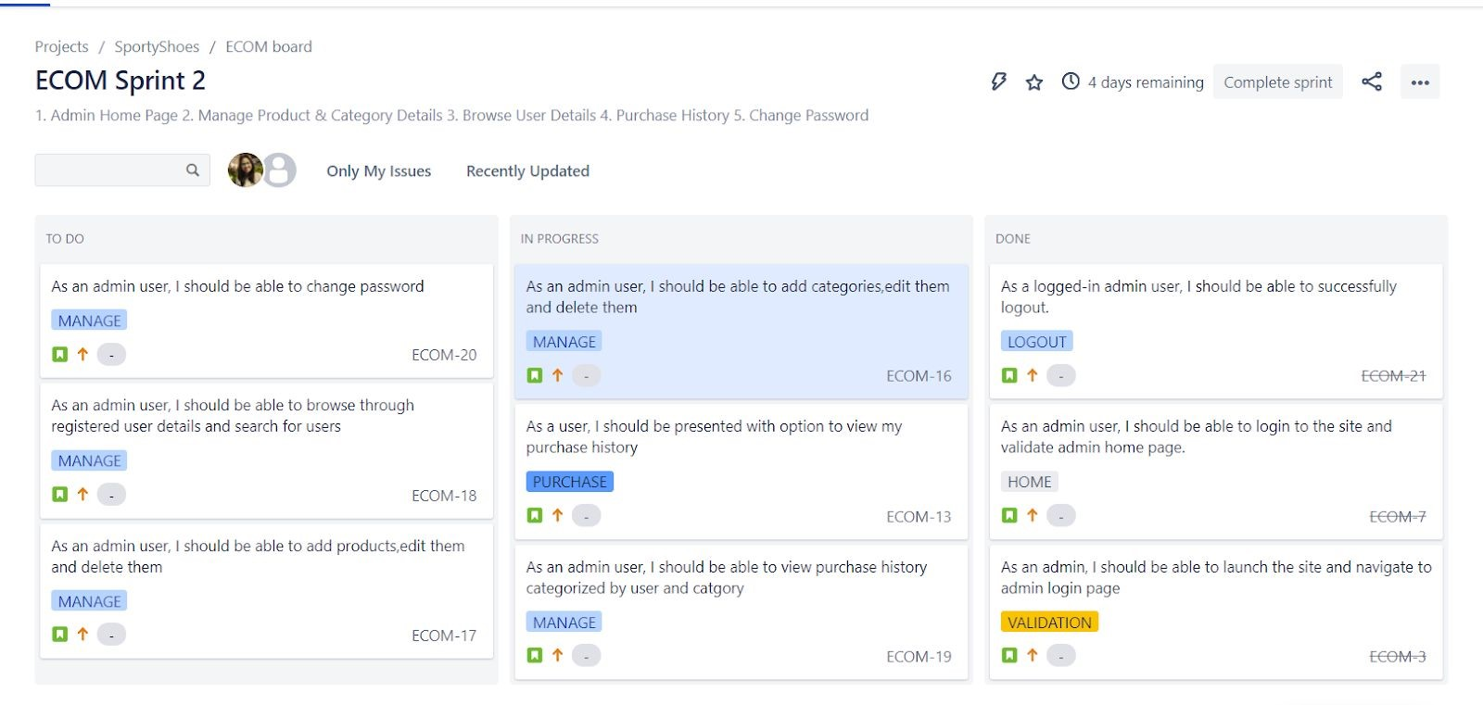

7.4

SPRINT 2 - REPORT

The sprint was completed successfully and all the planned goals were achieved within time.

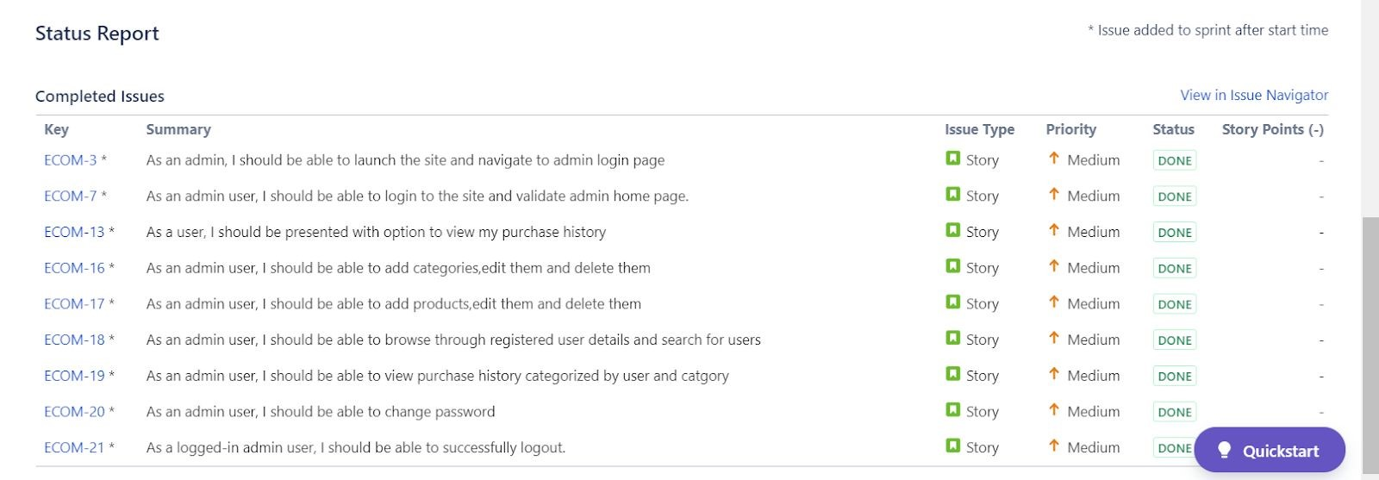

​*Fig: JIRA Sprint-2 Issue Status*

# 8. TOOLS AND TECHNOLOGIES

Development Methodology:

The application is developed in an Agile Manner. Scrum framework is adopted for development. The entire process was divided into 2 sprints and monitored using JIRA tools.

## Main Tools and Technologies

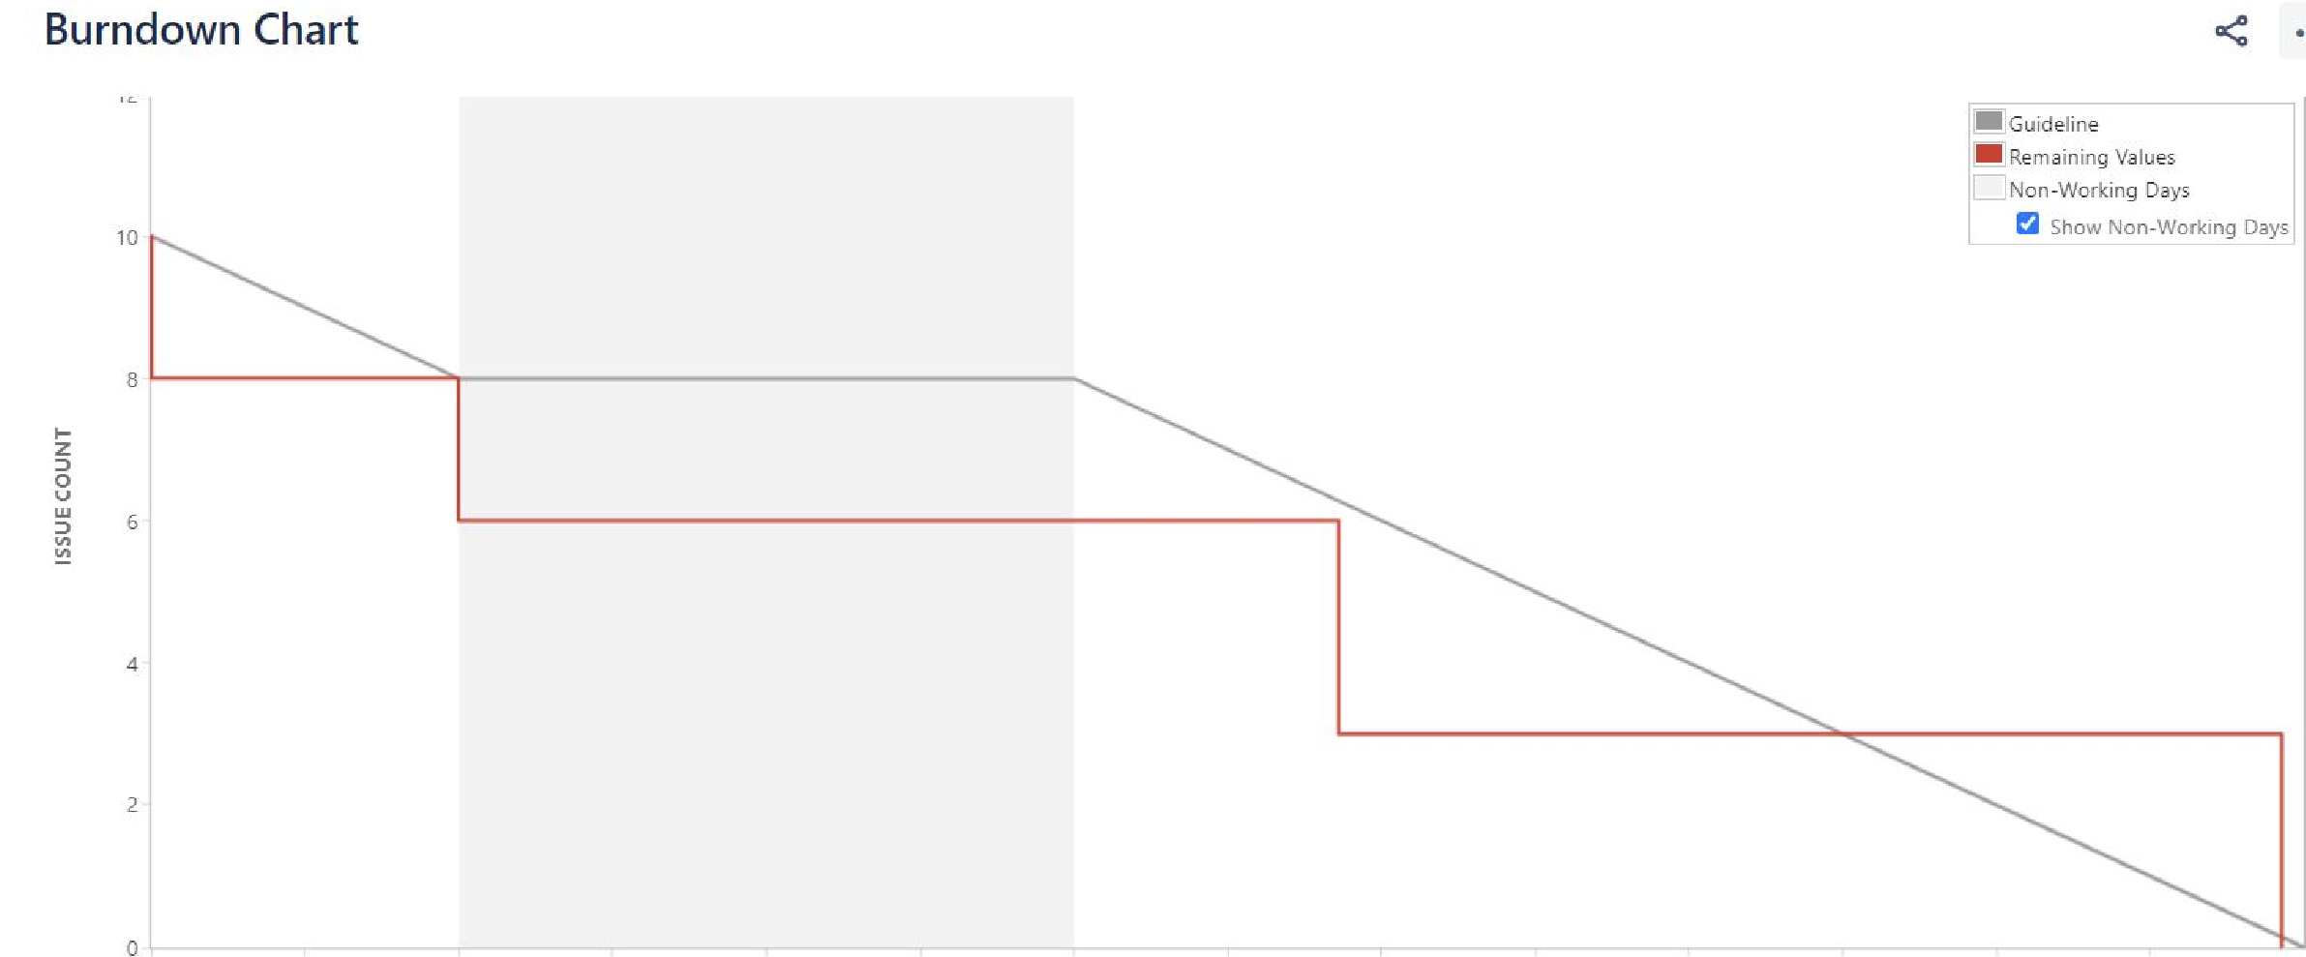

*Fig: JIRA Sprint-2 Burndown Chart*



* **Backend Programming Language: ​** ​Core Java.​ The software backend is completely developed in

Spring Boot. Key concepts and Technologies implemented are:

* 1. JSP
  2. Servlets
  3. Hibernate

Along with this, following critical Java concepts are also used:

* + 1. Collections
    2. Exception Handling
    3. Sorting

* **DataBase​**: ​MySQL ​ is used for creating DB
* **ORM​**: ​Hibernate ​is used as an ORM tool.
* **Front End: ​**HTML5 ​and ​CSS3 ​along with ​JavaScript ​is used in developing front-end.
* **Build​**: ​Maven ​with Spring MVC archetype is used in developing the application. ● **IDE:​ ​**STS
* **Version Control:​** ​Git​ and​ GitHub
* **Project Management and Sprint Planning:​** ​JIRA

# 9. SOURCE CODE ACCESS

The source code is pushed to GitHub repository. Please find the URL below for source code access:

***https://github.com/haritaToboso/SimpliLearn_P3_EcommerceShoeStore***

More details on setup and installation and how to run code can be found under ​README​.md document in the repository.

# 10. CONCLUSION

A prototype web application (version v1.0) has been created for Sporty Shoes E-commerce Portal . Designed and developed based on 100% agile way and completed over 2 sprints. Application has been delivered on time.

The source has been optimized by implementing core Spring concepts. The application is stable meeting all the criteria demanded for the prototype. Documented step-by-step processes starting from sprint planning to the product release.

## Future Scope

As this is version v1.0, only key functionalities have been implemented. Few of the suggestions from the developer's side for future implementations are:

Functionality

1. Sort using multiple categories like size, color etc.
2. More Secure Payment options
3. Chat Bot
4. Customer Helpline

Improvements

1. Scalability
2. Enhanced UI

Once the proposal is approved, discussions can be made on further enhancements.